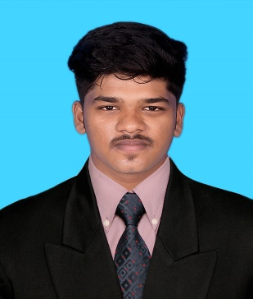**RAGUL R**

9360810280

ragulramesh1819@gmail.com

https://www.linkedin.com/in/ragul-r-1aba251ba/

91, South Street ,Sendurai, Ariyalur, Tamil Nadu - 621719

**OBJECTIVE**

To pursue my career in a leading organization which provides challenging work and allows me to grow professionally and as an individual.

**EDUCATION**

2021 **B.E-Computer Science and Engineering**

**Karpagam Academy of Higher Education**

CGPA-7.8(upto 4th sem)

2021 **H.S.C**

**Sri Ramakrishna Public School**

Percentage-80

2019 **S.S.L.C**

**Sri Ramakrishna Public School**

Percentage-71.2

**PROJECT**

Book It : “Efficient Appointment Management for Workers”

***Abstract :*** The project help the householders to fix the appointment for household repairs it is created by using the frontend tools as HTML,CSS and backend tool as SQL

**INTERNSHIP**

* PANTECH | Python Intern | 2022.

**TECHNICAL SKILLS**

Intermediate :

* C
* Java
* Python
* HTML
* CSS

**AREA OF INTEREST**

* Programming
* Web designing

**ACHIEVEMENTS**

* Solved more than 140+ programs in **Leetcode**
* Solved 1500+ problems in **SkillRack**

**CERTIFICATES**

* Certified in “Introduction to Python” from Infosys
* Certified in “Introduction to C” from Sololearn
* Certified in SQL from Scaler

**TECH PROFILE LINKS**

Coding Ninjas : <https://www.codingninjas.com/studio/profile/809e18c7-bc8d-44c9-8b93-0ead45cdb52f>

LeetCode : <https://leetcode.com/ragulramesh1819/>

SkillRack : <https://www.skillrack.com/faces/resume.xhtml?id=378295&key=befa15b0f34ec589f26b8e5610321b59bc114774>

**SOFT SKILLS**

* Teamwork
* Leadership
* Consistent

**DECLARATION**

I hereby declare that the details furnished above are true and correct to the best of my knowledge.

PLACE : Coimbatore [ RAGUL R ]

DATE: 05.03.2024